Success story - III
Breed savior award winner – 2015
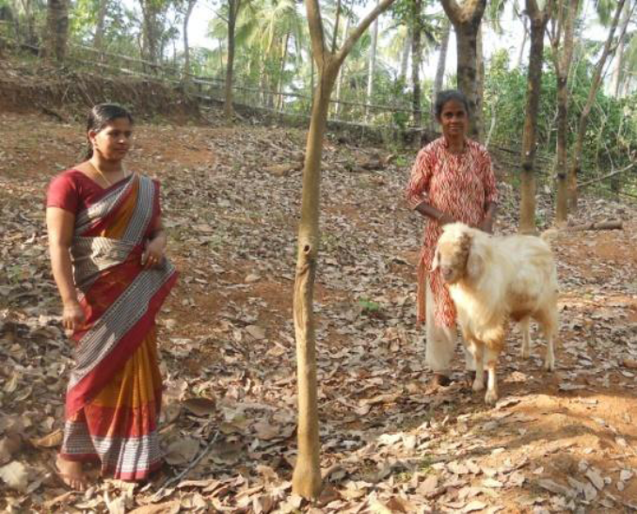
Name of Livestock Keeper: Smt. Santha Baby
Full Address: Edamana, Pandirikara, Avaduka (PO), Perambra.
Phone: 8086110817
Family Details:
Name | Sex | Age | Education | Occupation | Relationship
Smt. Santha Baby | F | 59 | Diploma in Nursing | Agriculture | Self
Sri Baby James. | M | 59 | High School | Agriculture | Husband
Sri. Shibu | M | 33 | High Scholle | Agriculture | Son

Smt. Santha Baby, Perambra is a farmer and owner of 4.5 acres land, started goat rearing three years ago as a small unit with two does, since the revenue from rubber plantation fell sharply. Subsequently AICRP registered the farmer as a beneficiary and created awareness on breeding, feeding and management practices. Now she is rearing a unit of 23 goats with the advice of AICRP on Malabari goat and started to realize the potential of sustained income. She sells 4-5 kids for breeding purpose and utilizes the manure for agriculture.

